

**REPUBLIC OF KENYA**

**MINISTRY OF LABOUR AND SOCIAL PROTECTION**

**State Department for Labour and Skills Development**

**REPORT ON EMPLOYABILITY SKILLS  
IN AGRICULTURE, MANUFACTURING AND CONSTRUCTION SECTORS**

**DIRECTORATE OF LABOUR MARKET RESEARCH AND ANALYSIS**

**JUNE, 2025**

# Preface



In alignment with Kenya's Vision 2030 and the Bottom-Up Economic Transformation Agenda, the Directorate of Labour Market Research and Analysis under the State Department for Labour and Skills Development undertook a task to produce quarterly indicators on employability skills within the manufacturing, agriculture and Construction sectors. The report tracks in-demand skills using web-scraped job vacancies and consolidates occupations into comparable skill areas to inform workforce planning, curriculum alignment, and policy action.

Kenya's Vision 2030 envisions a globally competitive nation by the year 2030. The MediumTerm Plan IV focuses on increasing employment opportunities and fostering economic growth. The Bottom-Up Economic Transformation Agenda emphasizes on creating jobs and driving inclusive economic growth through strategic interventions in key sectors such as manufacturing and agriculture.

The State Department for Labour and Skills Development plays a crucial role in realizing these visions by ensuring a well-prepared and skilled workforce. The Directorate of Labour Market Research and Analysis has the mandate to provide Labour market information by monitoring labour market trends, analyzing skill demands, and providing data-driven insights to support policy formulation and workforce development strategies.

This report consolidates the findings from the quarterly reports on employability skills in the manufacturing and agriculture sectors. It provides analysis of skill demands, and offers recommendations to bridge skill gaps and enhance the employability of the Kenyan workforce. Through this initiative, the Directorate aims to support the national agenda by fostering a skilled and adaptable workforce capable of meeting the evolving demands of the manufacturing and agriculture sectors.



# Acknowledgement

he State Department for Labour and Skills Development extends its heartfelt gratitude to the Directorate of Labour Market Research and Analysis for their dedicated and meticulous efforts in conducting the research that led to the comprehensive information presented in this document. Your thorough analysis and commitment to understanding the intricacies of the labor market have played a pivotal role in providing critical insights that will guide policy decisions aimed at improving the employability of our youth.

We would also like to offer special thanks to the Labour Market Observatory Unit for their tireless work in collecting, verifying, and compiling the vast amounts of data presented here. Your attention to detail and rigorous approach to ensuring the accuracy and reliability of the information is commendable.

This document, a result of your hard work and dedication, serves as an invaluable resource for shaping policies, interventions, and programs that will enhance the skills and employability of Kenyan youth. We trust that it will provide policymakers, educators, employers, and job seekers with the insights needed to address the evolving demands of the labor market. We remain hopeful that the information in this document will serve as a stepping stone toward a more prosperous and sustainable future for all.



**SHADRACK M. MWADIME, CBS**

**PRINCIPAL SECRETARY, STATE DEPARTMENT FOR LABOUR AND SKILLS DEVELOPMENT**

Table of Contents

Preface ii

Acknowledgement iii

1. Introduction 1

2. Scope of the Report 1

3. Methodology 1

4. Limitations 1

5. FINDINGS 1

5.1 Agriculture sector 1

5.2 Manufacturing sector 3

5.3 Construction sector 4

6. Cross-Sector View 6

7. CONCLUSION 6

8. RECOMMENDATION 6

**List of Tables**

*Table 1: Most Sought Skills in the Agriculture Sector (Apr–Jun 2025,) 2*

*Table 2: Most Sought Skills in the Manufacturing Sector (Apr–Jun 2025) 3*

*Table 3: Most Sought Skills in the Construction Sector (Apr–Jun 2025) 4*

**List of Figures**

*Figure 1: Most Sought Skills in the Agriculture Sector (Apr–Jun 2025) 2*

*Figure 2:Most Sought Skills in the Manufacturing Sector (Apr–Jun 2025) 4*

*Figure 3: Most Sought Skills in the Construction Sector (Apr–Jun 2025) 5*

*Figure 4:Skill Demand Comparison by Sector (Apr–Jun 2025) 6*

# 1. Introduction

As the economy continues to digitize and restructure, understanding which skills are most sought by employers is essential for responsive training and job-matching systems. This report analyses vacancies within three priority sectors—Agriculture, Manufacturing and Construction—and clusters occupations into skill areas to reveal clear, actionable demand patterns.

# 2. Scope of the Report

The analysis covers vacancies posted between April and June 2025 across the Agriculture, Manufacturing and Construction sectors. Occupations are collapsed into broader skill areas to enable like-for-like comparisons and to support curriculum and programme design. In this version, the residual category ‘Other / Support Services’ is excluded from tables and figures to focus attention on the core skill areas.

# 3. Methodology

**Data Source.** The report uses vacancies compiled from web-crawled job listings and cleaned into sector tables provided to the Directorate.

**Standardisation.** Occupational titles were normalised and grouped into skill areas via rule-based text classification. The taxonomy includes: Business Management & Administration; Engineering & IT; Sales, Marketing & Customer Relations; Financial & Mathematical; Transport & Logistics; Skilled Trades & Structural Work; and Core Agriculture.

**Aggregation.** Vacancies were summed within each skill area by sector. Percentages reflect each skill area’s share of the sectoral total after excluding the residual ‘Other / Support Services’.

**Quality Assurance.** Keyword rules were iteratively refined (e.g., mapping accountants to Financial & Mathematical; supervisors and clerks to Business Administration; operators/technicians to Skilled Trades; logistics/warehouse to Transport & Logistics; and engineering/ICT titles to Engineering & IT).

# 4. Limitations

Web postings may under-represent informal recruitment and certain sub-sectors. Titles can be broad and overlap multiple skill areas

# 5. FINDINGS

## 5.1 Agriculture sector

Agriculture remains the backbone of Kenya’s economy anchoring food security, rural livelihoods, and foreign-exchange earnings while supplying inputs to agro-processing and retail. Beyond primary production, the sector drives a wide services ecosystem (inputs, finance, logistics, extension) and is steadily formalizing and digitizing value chains. Current policy priorities including BETA’s push on value addition and market linkages are reinforcing demand for business administration, field sales, financial stewardship, engineering/ICT support, core technical agriculture, logistics, and selected trades across the farm-to-market space.

Table 1: Most Sought Skills in the Agriculture Sector (Apr–Jun 2025,)

|  |  |  |
| --- | --- | --- |
| **Skill Area** | **No. of Vacancies** | **Percent** |
| Business Management & Administration skills | 39 | 29.32% |
| Sales, Marketing & Customer Relations skills | 35 | 26.32% |
| Engineering & IT skills | 26 | 19.55% |
| Core Agriculture | 14 | 10.53% |
| Financial & numerical skills | 11 | 8.27% |
| Transport & Logistics skills | 5 | 3.76% |
| Skilled Trades & Structural Work skills | 3 | 2.26% |
| **TOTAL** | **133** | **100%** |

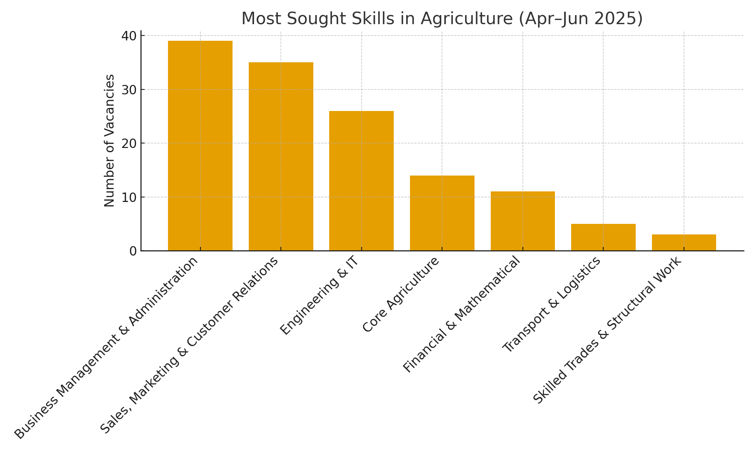

Figure 1: Most Sought Skills in the Agriculture Sector (Apr–Jun 2025)

Demand in agriculture clustered around Business Management & Administration (39; 29.3%) and Sales, Marketing & Customer Relations (35; 26.3%), signalling a sector run increasingly as integrated agribusiness—where coordination of inputs, growers and routes-to-market matters as much as field operations. Engineering & IT (26; 19.6%) reflects the digitisation of stock, finance and traceability workflows, while Core Agriculture (14; 10.5%) roles anchor extension and technical compliance. Financial & Mathematical (11; 8.3%) shows continued emphasis on cost control and credit vetting, with smaller but targeted needs in Transport & Logistics (5; 3.8%) and Skilled Trades (3; 2.3%) for movement of inputs/outputs and equipment upkeep.

Implications: Jobseekers gain the most by pairing agribusiness literacy with admin/HR, field sales/CRM, and basic ICT/ERP skills; short badges in credit appraisal, inventory and customer service raise employability. Training institutions should embed agribusiness operations, field selling & CRM, digital record-keeping and credit/inventory modules into diplomas, backed by attachments with agro-dealers and aggregators. For policy/investors, prioritise value-chain digitisation, structured TVET–industry placements, and working-capital tools that crowd-in hiring for business, sales and entry-level tech roles.

**Implications;**

* *Jobseekers:* Pair agribusiness literacy with practical admin/HR, field sales, and basic ICT. Short courses in credit appraisal, inventory control, and customer service will differentiate.
* *Training institutions:* Embed agribusiness operations, field selling and digital record-keeping/ERP into diplomas. Expand attachments with Agro-dealers/aggregators.
* *Policy & investors:* Support value-chain digitization (e-invoicing, stock traceability), targeted TVET–industry placements, and working-capital instruments that induce hiring in sales/admin and core tech support.

## 5.2 Manufacturing sector

Manufacturing is the engine of value addition and structural transformation turning local raw materials into competitive products, creating higher-productivity jobs, and deepening export capability. Industrial parks, quality standards, and MSME–industry linkages are expanding plant capacity and market reach, which, in turn, elevates demand for production engineering and Quality Assurance, commercial roles (sales, key accounts), cost/management accounting, logistics, and supervisory/administrative talent that keeps factories compliant, efficient, and customer-focused.

Table 2: Most Sought Skills in the Manufacturing Sector (Apr–Jun 2025)

|  |  |  |
| --- | --- | --- |
| **Skill Area** | **No. of Vacancies** | **Percent** |
| Sales, Marketing & Customer Relations skills | 153 | 32.35% |
| Business Management & Administration skills | 115 | 24.31% |
| Engineering & IT skills | 96 | 20.3% |
| Financial & numerical skills | 59 | 12.47% |
| Transport & Logistics | 24 | 5.07% |
| Skilled Trades & Structural Work | 20 | 4.23% |
| Core Agriculture | 6 | 1.27% |

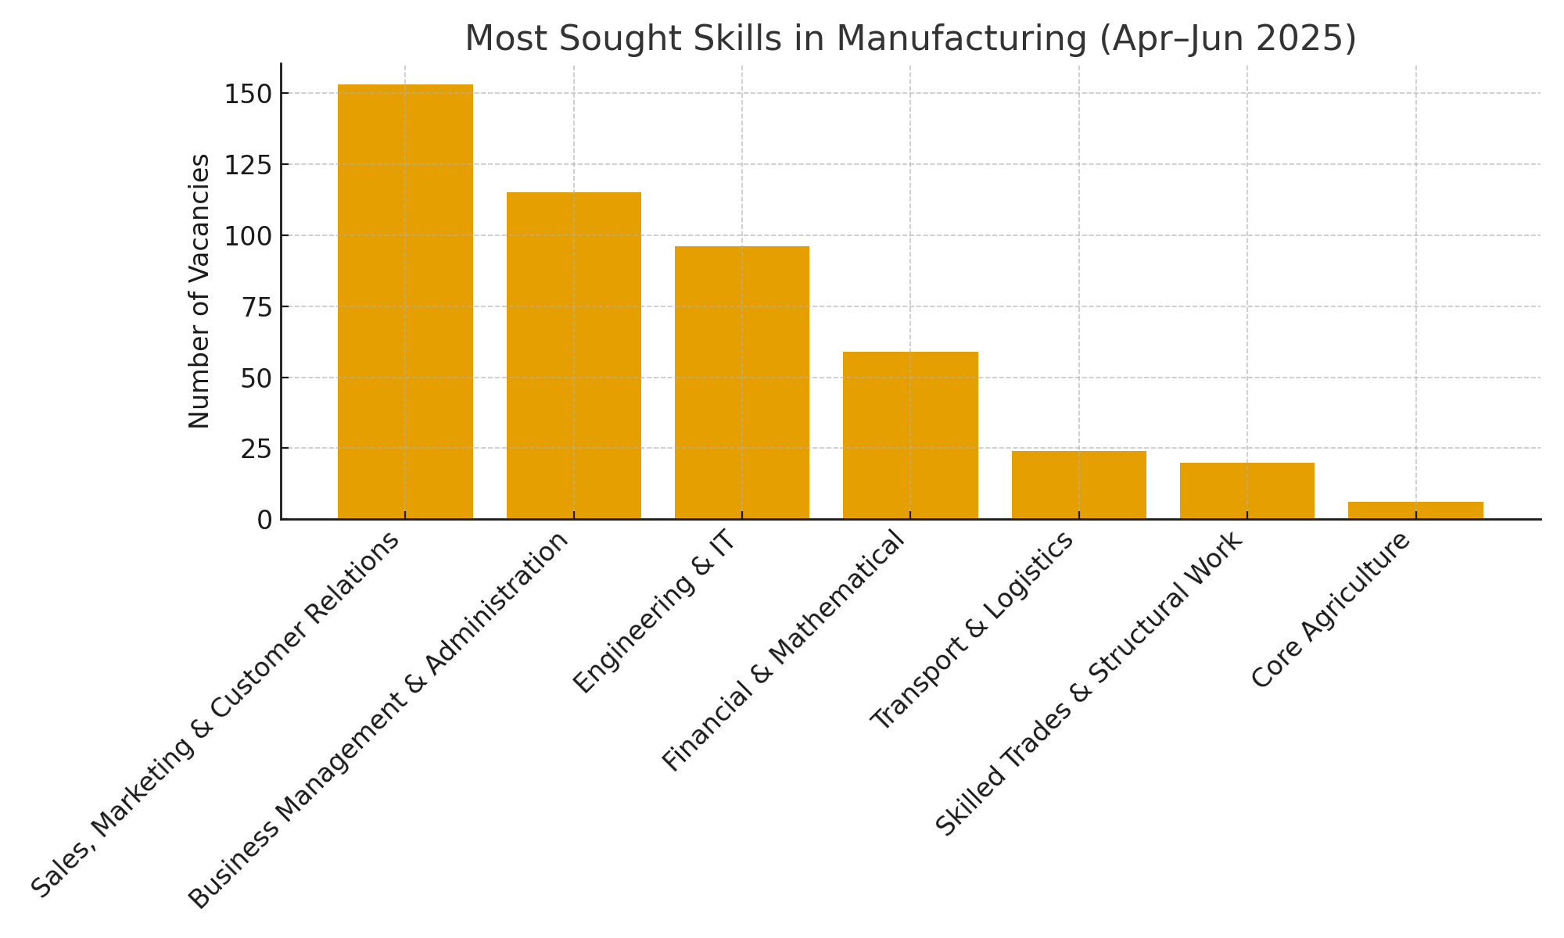

**Figure 2:Most Sought Skills in the Manufacturing Sector (Apr–Jun 2025)**

Manufacturing hiring leaned commercial and coordinated, Sales/Marketing & Customer Relations (153; 32.4%) and Business/Admin (115; 24.3%) led demand, indicating a push for volume growth, channel development and organised plant operations. Technical intensity remained significant through Engineering & IT (96; 20.3%) and Financial & Mathematical (59; 12.5%) a mix consistent with quality systems, automation and margin control. Transport & Logistics (24; 5.1%) and Skilled Trades (20; 4.2%) supported shop-floor continuity, while Core Agriculture (6; 1.3%) was marginal, as expected.

**Implications:**

* *Jobseekers* should blend commercial acumen (B2B selling, key-account management) with plant literacy
* *Training institutions* can scale dual pathways, factory attachments in QA/process control alongside sales/channel-management modules and add cost accounting for production.
* *Policy/investors* can spur quality jobs through standards/automation incentives, export-readiness programmes pairing sales with QA, and expanded industrial attachments tied to firm performance.

## 5.3 Construction sector

Construction is a catalyst for capital formation and employment, propelled by housing, transport, and social infrastructure projects. Its long supply chains stimulate upstream industries (cement, steel, fixtures) and downstream services (logistics, facilities management), multiplying jobs and enterprise opportunities.

**Table 3: Most Sought Skills in the Construction Sector (Apr–Jun 2025)**

|  |  |  |
| --- | --- | --- |
| **Skill Area** | **No. of Vacancies** | **Percent** |
| Engineering & IT skills | 31 | 39.74% |
| Business Management & Administration skills | 16 | 20.51% |
| Sales, Marketing & Customer Relations skills | 15 | 19.23% |
| Financial & Numerical skills | 12 | 15.38% |
| Skilled Trades & Structural Work | 2 | 2.56% |
| Transport & Logistics | 2 | 2.56% |

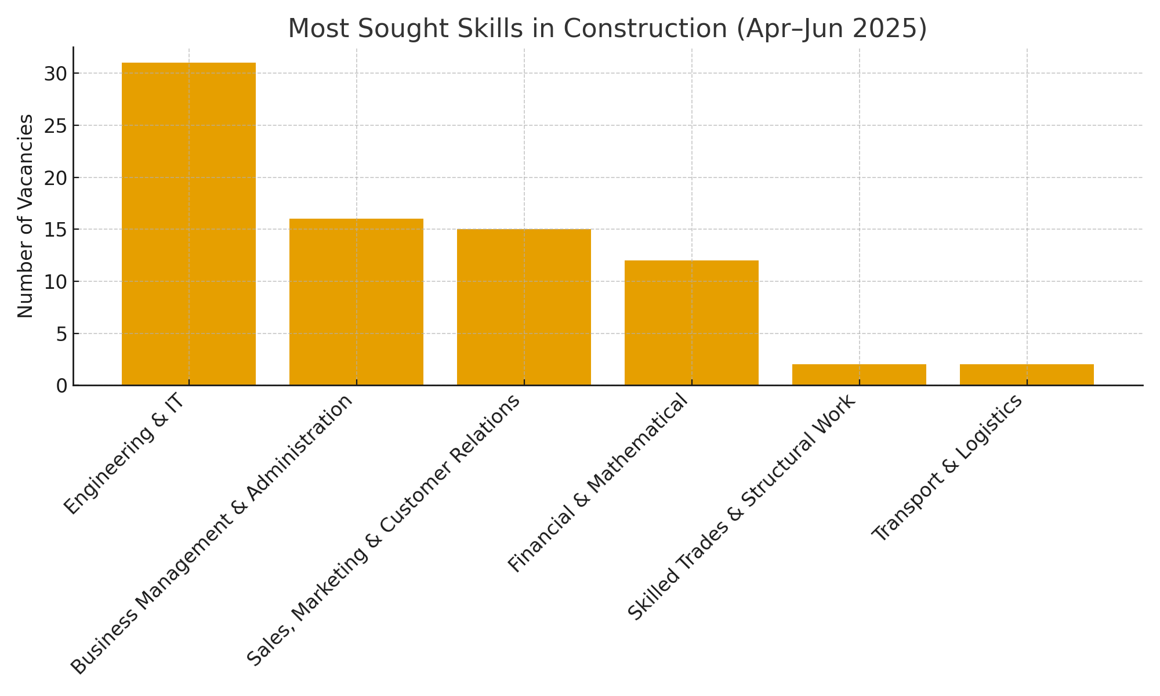

**Figure 3: Most Sought Skills in the Construction Sector (Apr–Jun 2025)**

Construction showed the highest technical concentration: Engineering & IT (31; 39.7%) dominated—covering site engineering, CAD/BIM support, testing and quality control—followed by Business/Admin (16; 20.5%) for project coordination and documentation and Sales/Marketing (15; 19.2%) for bid development and client liaison. Financial & Mathematical (12; 15.4%) underpinned cost discipline, while Skilled Trades (2; 2.6%) and Transport & Logistics (2; 2.6%) appeared as niche postings this quarter (much trades hiring likely occurs off-platform).

**Implications:**

* Jobseekers should prioritise digital construction, site QA/HSE, and project controls (scheduling, documentation).
* Training institutions need stronger modules on project administration and HSE, and site attachments exposing learners to real tendering and documentation cycles.
* Policy/investors can accelerate skilled hiring by promoting e-permitting, digital site diaries and standardised QA requirements in procurement, favouring firms that employ trained talent.

# 6. Cross-Sector View

Across sectors, demand concentrates in functional business roles, engineering/ICT, and sales/customer-facing roles. Manufacturing shows the largest absolute counts; Construction displays relatively higher technical intensity; and Agriculture presents a balanced mix including core agriculture roles.

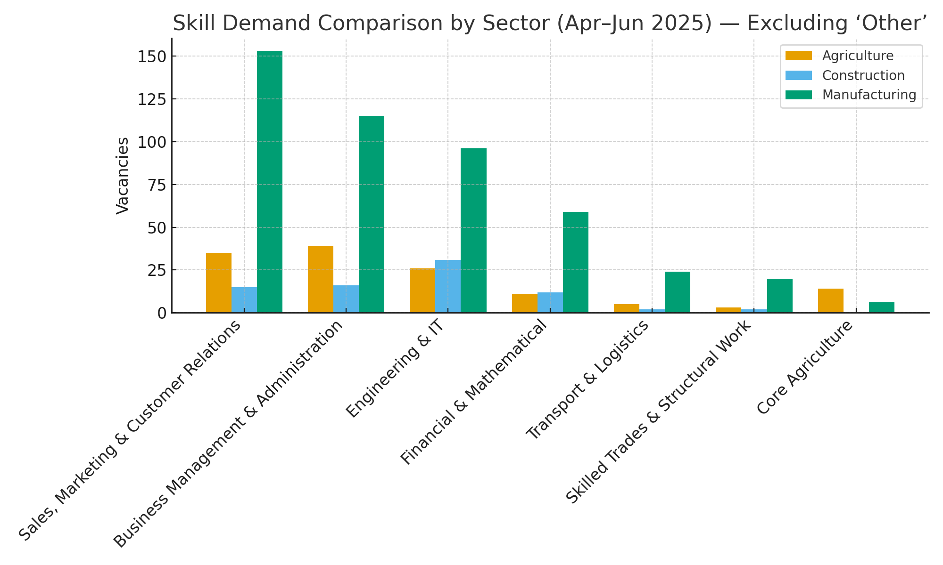

**Figure 4:Skill Demand Comparison by Sector (Apr–Jun 2025)**

# 7. CONCLUSION

Quarter 4 (April–June 2025) continues to show strong demand for business-facing, sales/market, and engineering/IT skills across Agriculture, Manufacturing and Construction, with sector-specific nuances that should inform targeted upskilling and job-matching through KLMIS and partners.

# 8. RECOMMENDATION

* **For Job Seekers.** Prioritise cross-cutting competencies in business operations, sales/customer engagement, and digital/engineering skills.
* **For Training Institutions.** Align curricula with observed clusters—industrial IT/automation, business administration, sales/customer relations, and technical trades.
* **For Policymakers.** Deepen industry–training linkages and expand short-cycle upskilling in digital, managerial, sales, and technical competencies.