

**REPUBLIC OF KENYA**

**MINISTRY OF LABOUR AND SOCIAL PROTECTION**

**State Department for Labour and Skills Development**

**APRIL - JUNE 2025**

**JOB TRENDS AND OPPORTUNITIES OUTLOOK IN KENYA**

**DIRECTORATE OF LABOUR MARKET RESEARCH AND ANALYSIS**

**April, 2025**

# PREFACE



This report provides a comprehensive analysis of the current job market landscape in Kenya, with a focus on the most sought-after occupations and the sectors having the highest number of vacancies1. Drawing insights from an extensive review of recent job advertisements across multiple platforms, it presents valuable data on the most in-demand roles and sectors showing significant growth within the Kenyan economy with their vacancy positions.

In a rapidly evolving job market, understanding where demand is concentrated is crucial. Job seekers can use these insights to identify available opportunities, while employers gain guidance on recruitment strategies and workforce planning. For policymakers and government planners, this report offers valuable input for effective manpower planning, skills development, and labor utilization. Furthermore, educators and training institutions can leverage the data to align their curricula with market needs, ensuring that the workforce is equipped with the relevant skills.

The insights presented in this report highlight not only the key occupations and roles driving demand but also the industries that are expanding and creating more job opportunities7. By analyzing the trends in job postings, this report aims to provide a clearer and more actionable picture of Kenya's dynamic employment environment. In doing so, it contributes to efforts aimed at addressing skills gaps, improving workforce planning, and fostering sustainable economic growth.

This report is designed for a wide range of stakeholders shaping Kenya’s employment landscape from job seekers and career advisors to business leaders, government bodies, and educational institutions. Through these findings, we hope to support the continued development of a robust, adaptable, and resilient labor market in Kenya, contributing to a thriving and prosperous workforce.



### ACKNOWLEDGEMENTS



The State Department for Labour and Skills Development extends its heartfelt gratitude to the Directorate of Labour Market Research and Analysis for their dedicated and meticulous efforts in conducting the research that led to the comprehensive information presented in this document. Your thorough analysis and commitment to understanding the intricacies of the labor market have played a pivotal role in providing critical insights that will guide policy decisions aimed at improving the employability of our youth.

We would also like to offer special thanks to the Labour Market Observatory Unit for their tireless work in collecting, verifying, and compiling the vast amounts of data presented here. Your attention to detail and rigorous approach to ensuring the accuracy and reliability of the information is commendable. This document, a result of your hard work and dedication, serves as an invaluable resource for shaping policies, interventions, and programs that will enhance the skills and employability of Kenyan youth.

We trust that it will provide policymakers, educators, employers, and job seekers with the insights needed to address the evolving demands of the labor market. We remain hopeful that the information in this document will serve as a stepping stone toward a more prosperous and sustainable future for all



**SHADRACK M. MWADIME, CBS**

**PRINCIPAL SECRETARY, STATE DEPARTMENT FOR LABOUR AND SKILLS DEVELOPMENT**

# EXECUTIVE SUMMARY

During April–June 2025, the Kenyan labour market was dominated by service-oriented and knowledge-driven sectors. Financial and Insurance Activities led recruitment (14.4%), followed by Education (12.8%) and Human Health & Social Work (11.4%). Together, these three sectors generated more than one-third of all job postings. Administrative & Support Services (10.7%) and Public Administration (10.4%) also remained strong contributors.  
  
Professionals accounted for the largest share of demand (38.1%), followed by Managers (27.6%) and Technicians & Associate Professionals (19.9%). This distribution highlights the economy’s heavy reliance on higher-skilled labour, with limited absorption of low-skilled workers.  
  
At the occupational level, high demand was observed for Commercial Sales Representatives, Finance Managers, Managing Directors & CEOs, University Lecturers, and Software Developers. Middle-skill demand was concentrated in clerical, customer service, and transport-related roles, while low-skill recruitment was mainly in cleaning, kitchen support, and freight handling.  
  
Across specific sectors, job demand reflected national priorities: governance and infrastructure (Public Administration), healthcare expansion (Human Health & Social Work), financial deepening (Financial Services), educational growth (Education), and administrative efficiency (Administrative & Support Services).  
  
Overall, the quarter underscored a strong tilt towards professional, managerial, and technical occupations, signalling the continued importance of aligning training and skilling initiatives with the evolving demands of Kenya’s labour market.

Table of Contents

PREFACE ii

ACKNOWLEDGEMENTS iii

EXECUTIVE SUMMARY iv

1. INTRODUCTION 1

2. SCOPE 1

3. METHODOLOGY 1

4. FINDINGS 2

4.1 NUMBER OF JOB VACANCIES ADVERTISED BY SECTOR 2

4.2 NUMBER OF JOB VACANCIES ADVERTISED BY MAJOR OCCUPATIONAL GROUP 4

4.3 NUMBER OF VACANCIES BY SKILL LEVEL AND OCCUPATIONS 5

4.4 TOP 10 OCCUPATIONS WITHIN FIVE KEY HIRING SECTORS 8

4.4.1 Public administration and defense; compulsory social security sector 8

5. CONCLUSION 13

6. RECOMMENDATIONS 13

**List of Tables**

Table 1: Top Job Vacancies by Sector 1

Table 2: Job Vacancies by Major Occupational Group 4

Table 3:Top 10 Most Sought Occupations for Highly Skilled 5

Table 4: Top 10 Most Sought Occupations for Middle Skilled 6

Table 5: Top 10 Most Sought Occupations for Low Skilled 7

Table 6: Top 10 Occupations in Public administration and defense; compulsory social security sector 8

Table 7: Top 10 Occupations in Human health and social work activities 9

Table 8: Top Occupations in Financial and insurance activities 10

Table 9: Top 10 Occupations in Education sector 11

Table 10: Top 10 Occupations in Administrative and support service activities 12

**List of Figures**

Figure 1: Job Vacancies Advertised by Sector 3

Figure 2: Proportion Of Vacancies by Major Occupational Group 4

Figure 3: Top 10 Most Sought Occupations for Highly Skilled 5

Figure 4:Top 10 Most Sought Occupations for Middle Skilled 6

Figure 5:Top 10 Most Sought Occupations for Low Skilled 7

Figure 6: Top 10 Occupations in Public administration and defense; compulsory social security sector 9

Figure 7: Top 10 Occupations in Human health and social work activities 10

Figure 8:Top Occupations in Financial and insurance activities 11

Figure 9:Top 10 Occupations in Education sector 12

Figure 10: Top 10 Occupations in Administrative and support service activities 13

# INTRODUCTION

Unemployment remains one of the most pressing socio-economic challenges in Kenya, particularly among the youth. According to the Kenya National Bureau of Statistics (KNBS), the unemployment rate stood at around 5.7% in 2023, with young people aged 15–34 years being the most affected. The high number of job seekers entering the labour market each year outpaces the available job opportunities, leading to increased joblessness. Additionally, many employed individuals remain in vulnerable or informal jobs that offer little security or growth potential.

A significant factor contributing to unemployment is the mismatch between labour market demands and the skills possessed by job seekers. The International Labour Organization (ILO) highlights that many young graduates globally, including in Kenya, struggle to secure meaningful employment due to a lack of industry-relevant skills. Rapid technological advancements and automation have also displaced low-skilled workers, further limiting opportunities in traditionally labour-intensive sectors.

To address these challenges, reliable and timely labour market information is essential. By providing insights into hiring trends, emerging occupations, and skill demands, this report aims to support evidence-based decision-making for policymakers, training institutions, job seekers, and employers. This analysis of job vacancies in Kenya for the period April - June 2025 will help bridge information gaps, align education and training programs with market needs, and facilitate more effective workforce planning.

# SCOPE

The analysis covers online job advertisements posted during April–June 2025 across multiple recruitment platforms. Industries were mapped to the Kenya Standard Industrial Classification (KeSIC) while occupations were coded to the Kenya Standard Classification of Occupations (KeSCO). Metrics include counts and shares of vacancies by sector, major occupational group, and skill level, in addition to leading occupations in top hiring sectors.

# METHODOLOGY

Vacancy data was collected through automated web crawling of online job boards. The data was cleaned, de-duplicated, and standardized before analysis. Occupations were coded according to KeSCO 2014 and sectors classified under KeSIC Rev. 2.1. Tabulations and charts were produced using Python and Stata to ensure consistency and reliability of findings.

# FINDINGS

## 4.1 NUMBER OF JOB VACANCIES ADVERTISED BY SECTOR

Table 1: Number of Vacancies by Sector

|  |  |  |
| --- | --- | --- |
| **SECTOR** | **No. OF VACANCIES** | **%** |
| Financial and insurance activities | 1608 | 14.41 |
| Education | 1422 | 12.75 |
| Human health and social work activities | 1273 | 11.41 |
| Administrative and support service activities | 1192 | 10.68 |
| Public administration and defense; compulsory social security | 1159 | 10.39 |
| Professional, scientific and technical activities | 832 | 7.46 |
| Activities of extraterritorial organization | 649 | 5.82 |
| Information and communication | 572 | 5.13 |
| Manufacturing | 526 | 4.71 |
| Wholesale and retail trade; repair of motor vehicles and motorcycles | 414 | 3.71 |
| Accommodation and food service activities | 345 | 3.09 |
| Other service activities | 262 | 2.35 |
| Transportation and storage | 250 | 2.24 |
| Electricity, gas, steam and air conditioning supply | 198 | 1.77 |
| Agriculture, forestry and fishing | 137 | 1.23 |
| Real estate activities | 135 | 1.21 |
| Construction | 85 | 0.76 |
| Water supply; sewerage, waste management and remediation activities | 64 | 0.57 |
| Mining and quarrying | 18 | 0.16 |
| Activities of households as employers | 8 | 0.07 |
| Arts, entertainment and recreation | 7 | 0.06 |
| **Total** | **11156** | **100.0** |

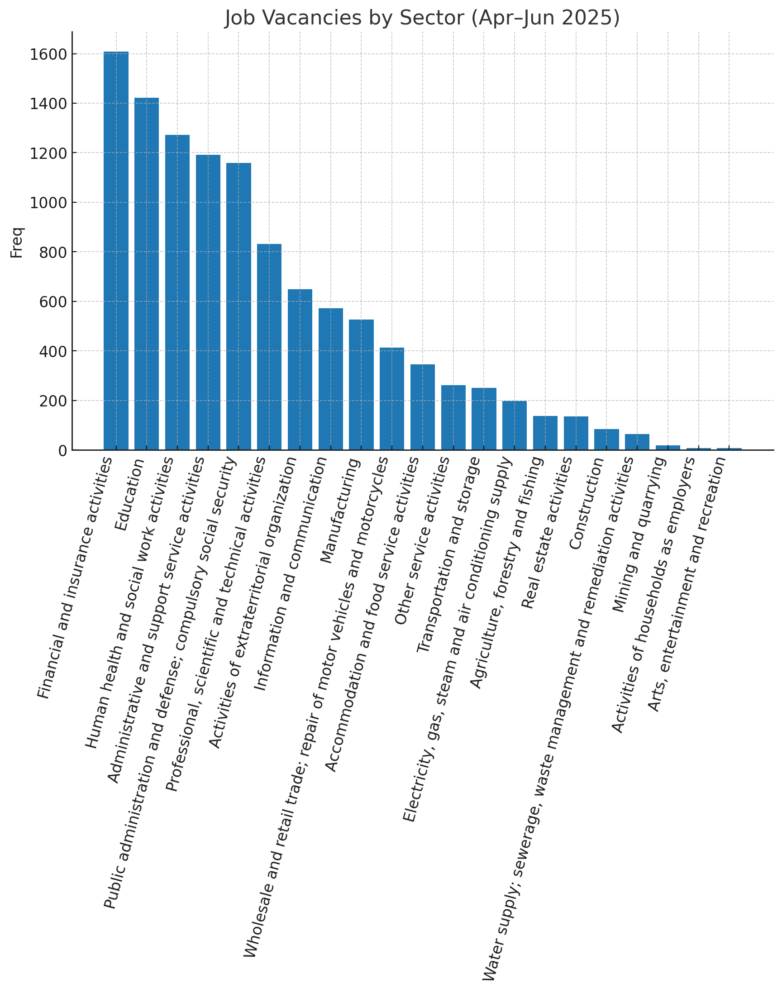

Figure 1: Job Vacancies by Sector

Vacancies in Financial and Insurance Activities led the quarter with 14.4% of total postings, followed closely by Education (12.8%) and Human Health and Social Work Activities (11.4%). These three accounted for more than a third of all opportunities, highlighting sustained demand in knowledge-intensive and service-oriented sectors. Administrative and Support Services (10.7%) and Public Administration (10.4%) also featured prominently. In contrast, agriculture and construction contributed minimally, underscoring a structural tilt towards services.

## 4.2 NUMBER OF JOB VACANCIES ADVERTISED BY MAJOR OCCUPATIONAL GROUP

Table 2: Number of Vacancies by Major Occupational Group

|  |  |  |
| --- | --- | --- |
| **MAJOR OCCUPATIONAL GROUP** | **N0. OF VACANCIES** | **%** |
| PROFESSIONALS | 4217 | 38.1 |
| LEGISLATORS, ADMINISTRATORS AND MANAGERS | 3062 | 27.6 |
| TECHNICIANS AND ASSOCIATE PROFESSIONAL | 2200 | 19.9 |
| SECRETARIAL, CLERICAL SERVICES AND RELATED WORKERS | 886 | 8 |
| SERVICE WORKERS, SHOP AND MARKET SALES WORKERS | 348 | 3.1 |
| PLANT AND MACHINE OPERATORS AND ASSEMBLERS | 174 | 1.6 |
| CRAFT AND RELATED TRADES WORKERS | 120 | 1.1 |
| ELEMENTARY OCCUPATIONS | 53 | 0.5 |
| SKILLED AGRICULTURAL, FORESTRY AND FISHING WORKERS | 18 | 0.2 |
| TOTAL | 11078 | 100 |

Figure 2: Job Vacancies by Major Occupational Group

Professionals dominated recruitment, accounting for 38.1% of advertised jobs. This was followed by Legislators, Administrators and Managers (27.6%), and Technicians and Associate Professionals (19.9%). These three groups combined captured over 85% of the quarter’s postings, confirming that Kenya’s labour market is strongly skewed towards higher skill tiers. Elementary occupations (0.5%) and agricultural/fishery roles (0.2%) remained negligible.

## 4.3 NUMBER OF VACANCIES BY SKILL LEVEL AND OCCUPATIONS

Table 3:Top 10 Most Sought Occupations for Highly Skilled

|  |  |  |
| --- | --- | --- |
| **OCCUPATIONS** | **No. OF VACANCIES** | **%** |
| Commercial Sales Representatives | 679 | 7.16 |
| Finance Managers | 570 | 6.01 |
| Managing Directors and Chief Executives | 568 | 5.99 |
| Sales and Marketing Managers | 497 | 5.24 |
| University and College Lecturers | 488 | 5.15 |
| Policy and Planning Managers | 391 | 4.13 |
| Accountants | 362 | 3.82 |
| Software Developers | 268 | 2.83 |
| Public Relations Professionals | 206 | 2.17 |
| Systems Analysts | 189 | 1.99 |

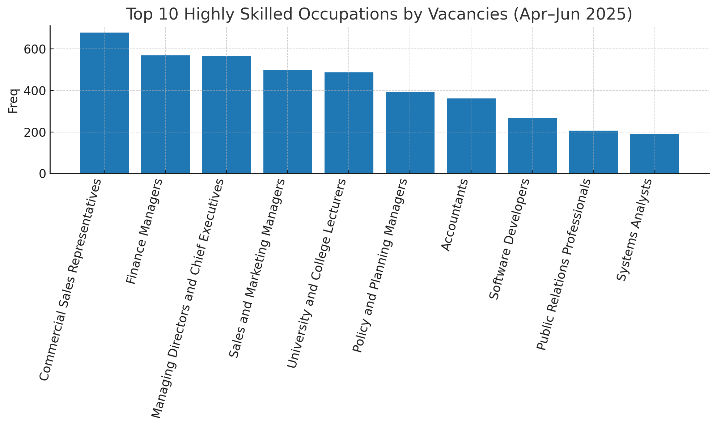

Figure 3: Top 10 Most Sought Occupations for Highly Skilled

The top highly skilled roles included Commercial Sales Representatives, Finance Managers, Managing Directors & CEOs, Sales & Marketing Managers, and University Lecturers. This indicates strong demand for leadership, financial management, and advanced teaching roles. Tech-related roles such as Software Developers and Systems Analysts also featured prominently, signalling Kenya’s ongoing digital transformation.

**4.3.2 Top 10 Most Sought Occupations for Middle Skilled**

Table 4: Top 10 Most Sought Occupations for Middle Skilled

|  |  |  |
| --- | --- | --- |
| **OCCUPATIONS** | **No. OF VACANCIES** | **%** |
| Personnel Clerks | 247 | 15.99 |
| Contact Centre Information Clerks | 110 | 7.12 |
| Car, Taxi and Van Drivers | 86 | 5.57 |
| Stock Clerks | 81 | 5.24 |
| Cleaning and Housekeeping-Non Domestic | 62 | 4.01 |
| Security Guards | 61 | 3.95 |
| Data Entry Clerks | 51 | 3.3 |
| Accounting And Book Keeping Clerks | 50 | 3.24 |
| Contact Centre Salespersons | 49 | 3.17 |
| Statistical, Finance and Insurance Clerks | 48 | 3.11 |

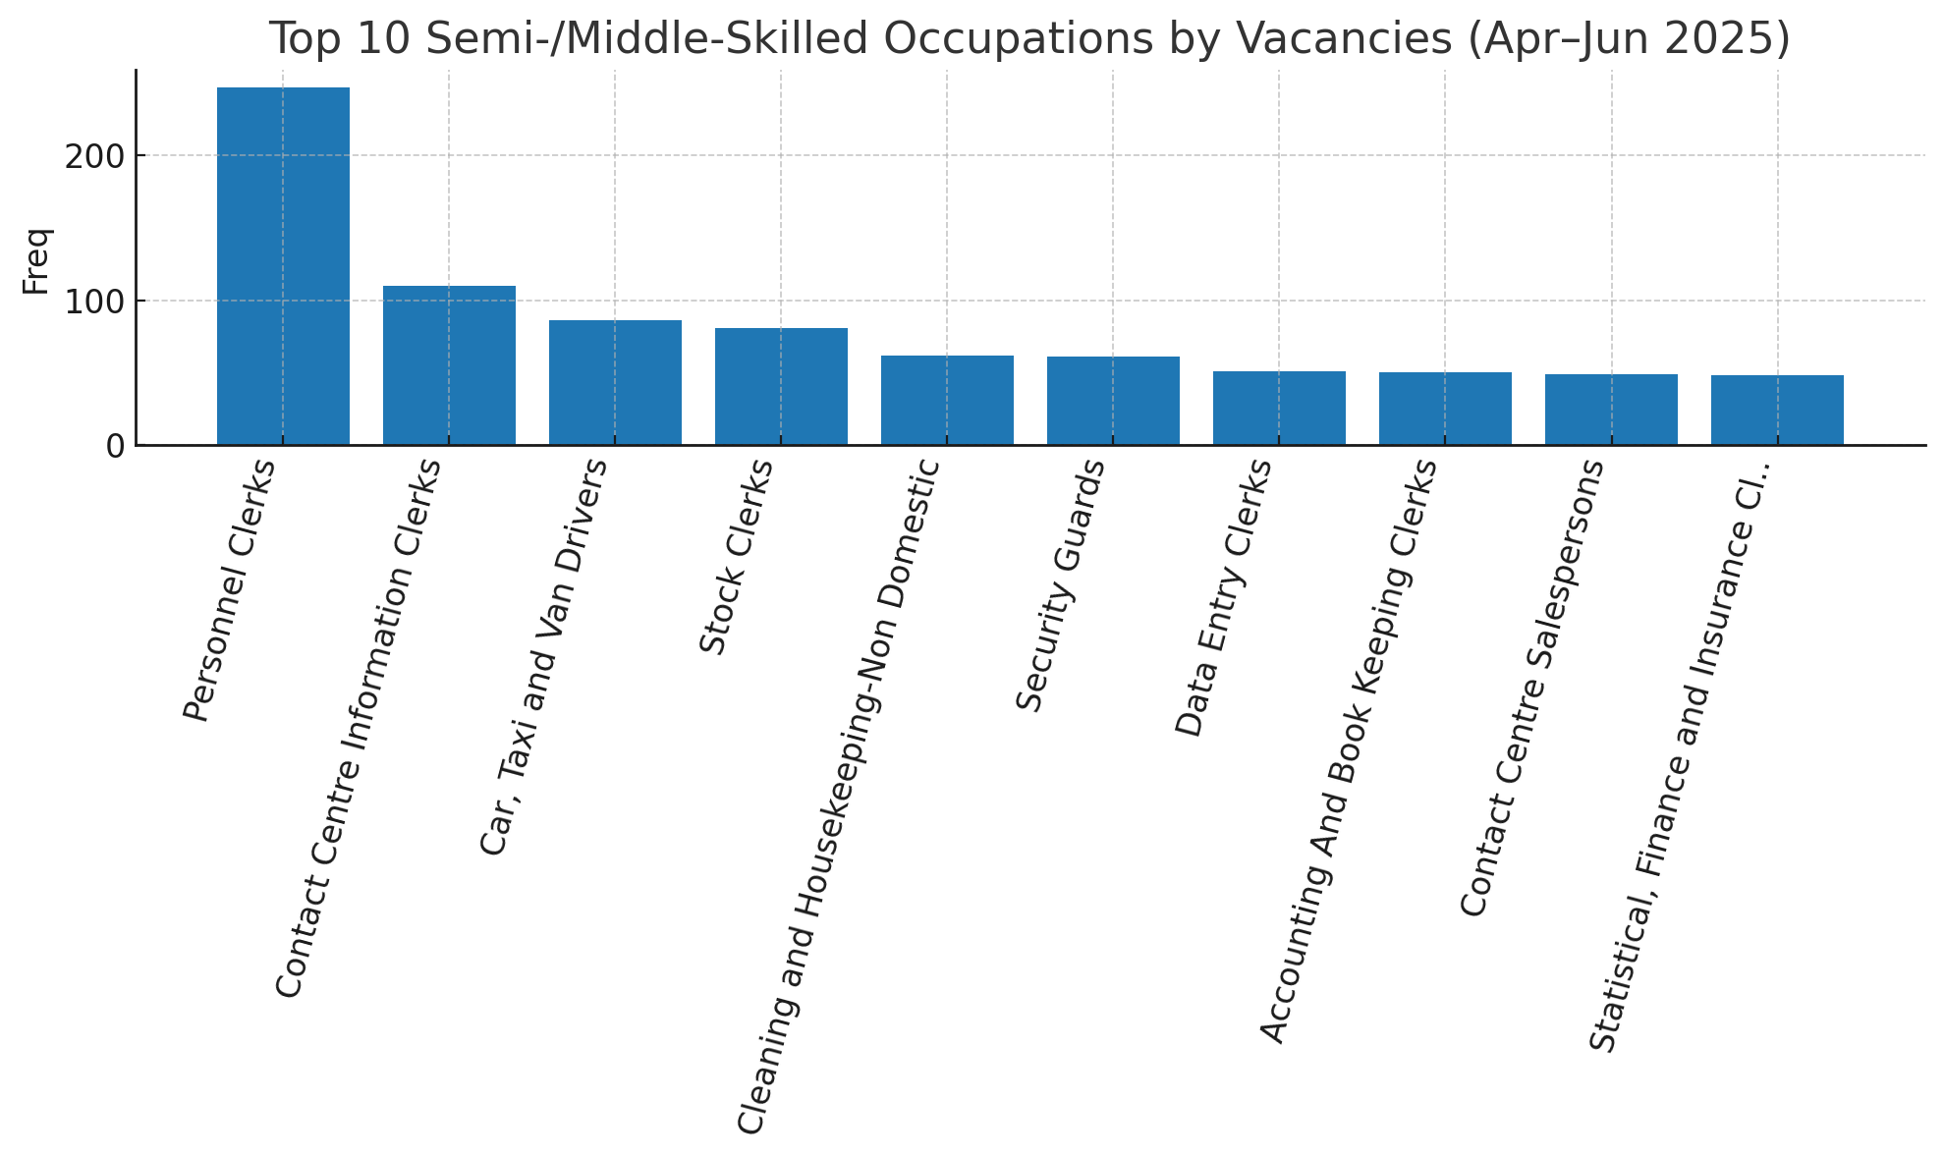

Figure 4:Top 10 Most Sought Occupations for Middle Skilled

The most sought-after middle-skilled roles were Personnel Clerks, Contact Centre Information Clerks, Car/Taxi Drivers, Stock Clerks, and Housekeeping Supervisors. This reflects demand in clerical support, customer service, and logistics functions, which are critical for sustaining business operations.

**4.3.3 Most Sought Occupations for Low Skilled**

Table 5: Top 10 Most Sought Occupations for Low Skilled

|  |  |  |
| --- | --- | --- |
| **OCCUPATIONS** | **No. OF VACANCIES** | **%** |
| Cleaners and Helpers In Offices, Hotels | 17 | 32.08 |
| Kitchen Helpers | 14 | 26.42 |
| Freight Handlers | 6 | 11.32 |
| Odd Job Persons | 4 | 7.55 |
| Building Construction Labourers | 2 | 3.77 |
| Farm Labourers | 2 | 3.77 |
| Fishery and Aquaculture Labourers | 2 | 3.77 |
| Other Manufacturing Labourers | 2 | 3.77 |
| Civil Engineering Labourers | 1 | 1.89 |
| Hand Launderers And Pressers | 1 | 1.89 |

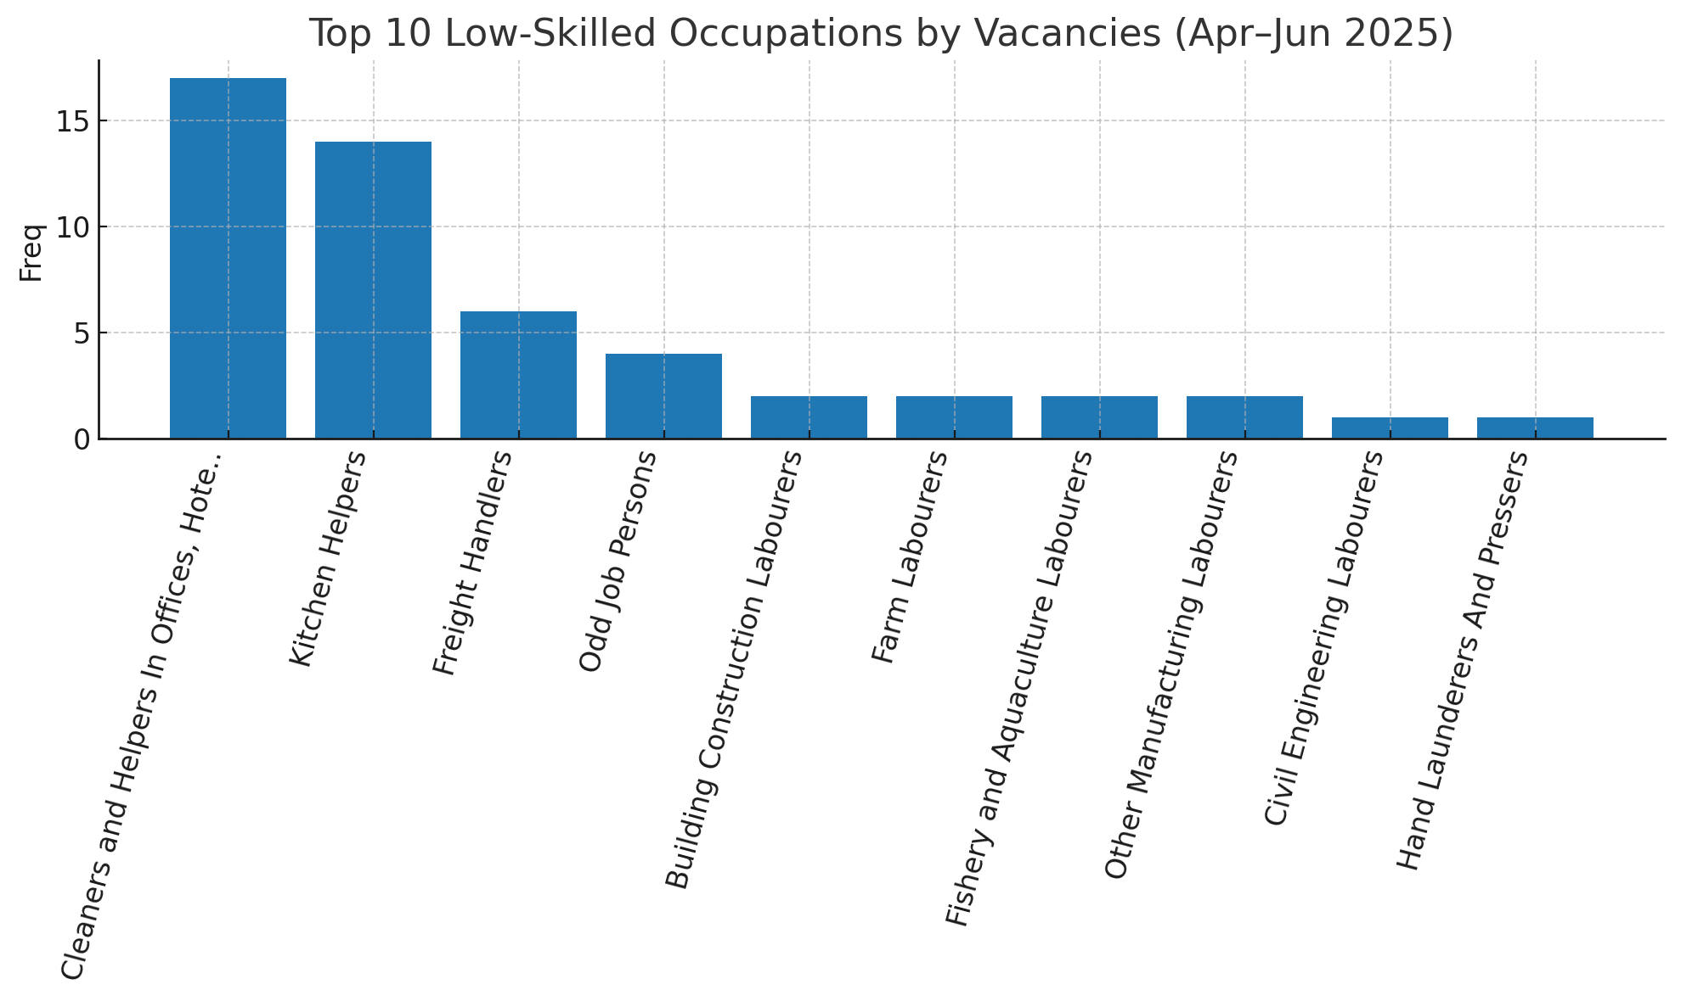

Figure 5:Top 10 Most Sought Occupations for Low Skilled

Recruitment at the low-skill tier was concentrated in Cleaners, Kitchen Helpers, and Freight Handlers, showing limited but stable demand for essential support roles. Their overall shares remain small compared to high- and mid-skill categories, reflecting Kenya’s gradual shift towards a more skill-intensive labour market or a grow in informal recruitment channels for low-skilled roles.

## 4.4 TOP 10 OCCUPATIONS WITHIN FIVE KEY HIRING SECTORS

### 4.4.1 Public administration and defense; compulsory social security sector

**Table 6:** **Top 10 Occupations in Public administration**

|  |  |  |
| --- | --- | --- |
| **OCCUPATIONS** | **NUMBER OF VACANCIES** | **PERCENTAGE** |
| Managing Directors and Chief Executives | 177 | 15.32 |
| Early Childhood Development Teachers | 55 | 4.76 |
| Car, Taxi and Van Drivers | 43 | 3.72 |
| Accountants | 39 | 3.38 |
| Administrative and Executive Secretaries | 31 | 2.68 |
| County Government Administrators | 31 | 2.68 |
| Civil Engineers | 28 | 2.42 |
| Public Relations Professionals | 24 | 2.08 |
| Lawyers | 24 | 2.08 |
| Manager Health Care Services | 23 | 1.99 |

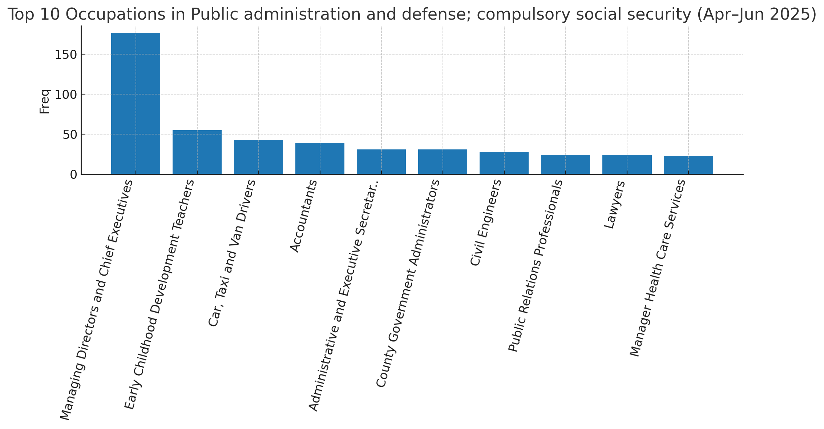

**Figure 6: Top 10 Most Sought Occupations in Public administration**

Public Administration & Defense concentrated on Managing Directors/CEOs, County Administrators, Lawyers, and Civil Engineers, underscoring governance and infrastructure priorities.

**4.4.2 Human health and social work activities**

Table 7: Top 10 Most Sought Occupations in Human health and social work activities

|  |  |  |
| --- | --- | --- |
| **OCCUPATIONS** | **NUMBER OF VACANCIES** | **PERCENTAGE** |
| Managing Directors and Chief Executives | 83 | 6.69 |
| Nurse, General | 69 | 5.56 |
| Finance Managers | 68 | 5.48 |
| Accountants | 50 | 4.03 |
| Pharmaceutical Technicians and Assistants | 41 | 3.3 |
| Specialist Medical Practitioners | 36 | 2.9 |
| Personnel Clerks | 35 | 2.82 |
| Policy and Planning Managers | 34 | 2.74 |
| Manager Health Care Services | 33 | 2.66 |
| Public Relations Professionals | 28 | 2.26 |

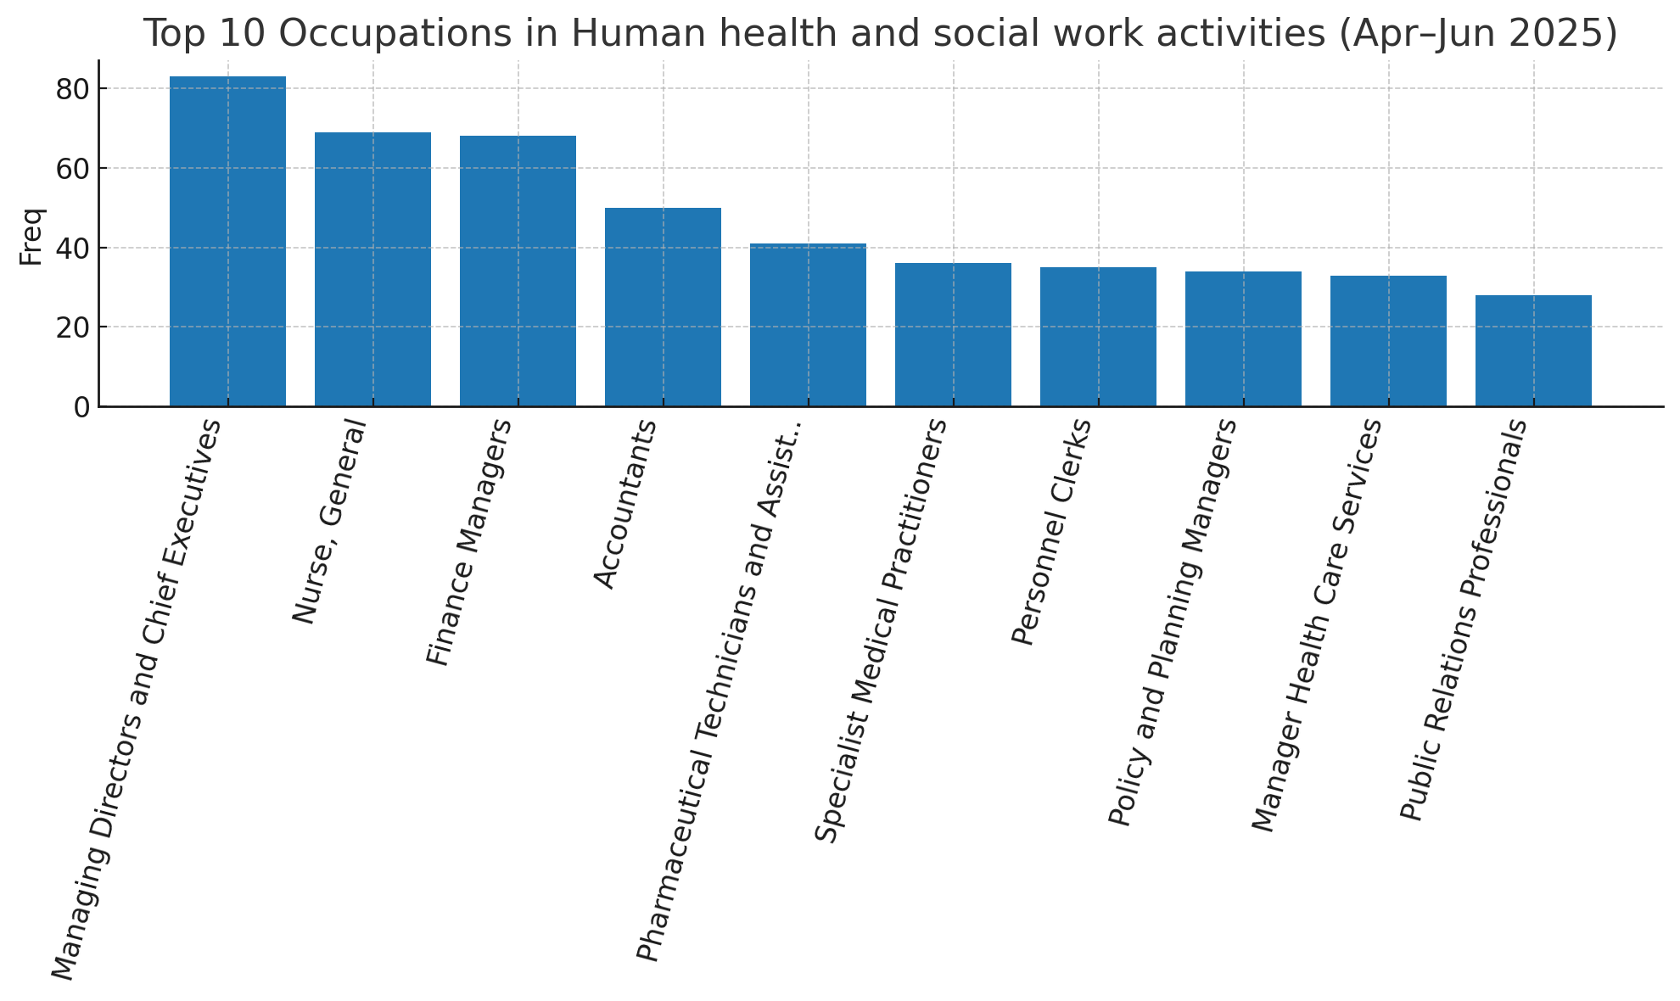

Figure 7: Top 10 Most Sought Occupations in Human health and social work activities

Human Health & Social Work recruitment was led by Nurses, Specialist Medical Practitioners, and Pharmaceutical Technicians, reflecting healthcare expansion.

**4.4.3 Financial and insurance activities**

**Table 8: Top 8 Most Sought Occupations in Financial and insurance activities**

|  |  |  |
| --- | --- | --- |
| **OCCUPATIONS** | **NUMBER OF VACANCIES** | **PERCENTAGE** |
| Finance Managers | 216 | 13.47 |
| Commercial Sales Representatives | 116 | 7.24 |
| Sales and Marketing Managers | 100 | 6.24 |
| Policy and Planning Managers | 77 | 4.8 |
| Public Relations and Advertising Managers | 75 | 4.68 |
| Insurance Representatives | 73 | 4.55 |
| Software Developers | 62 | 3.87 |
| Public Relations Professionals | 53 | 3.31 |

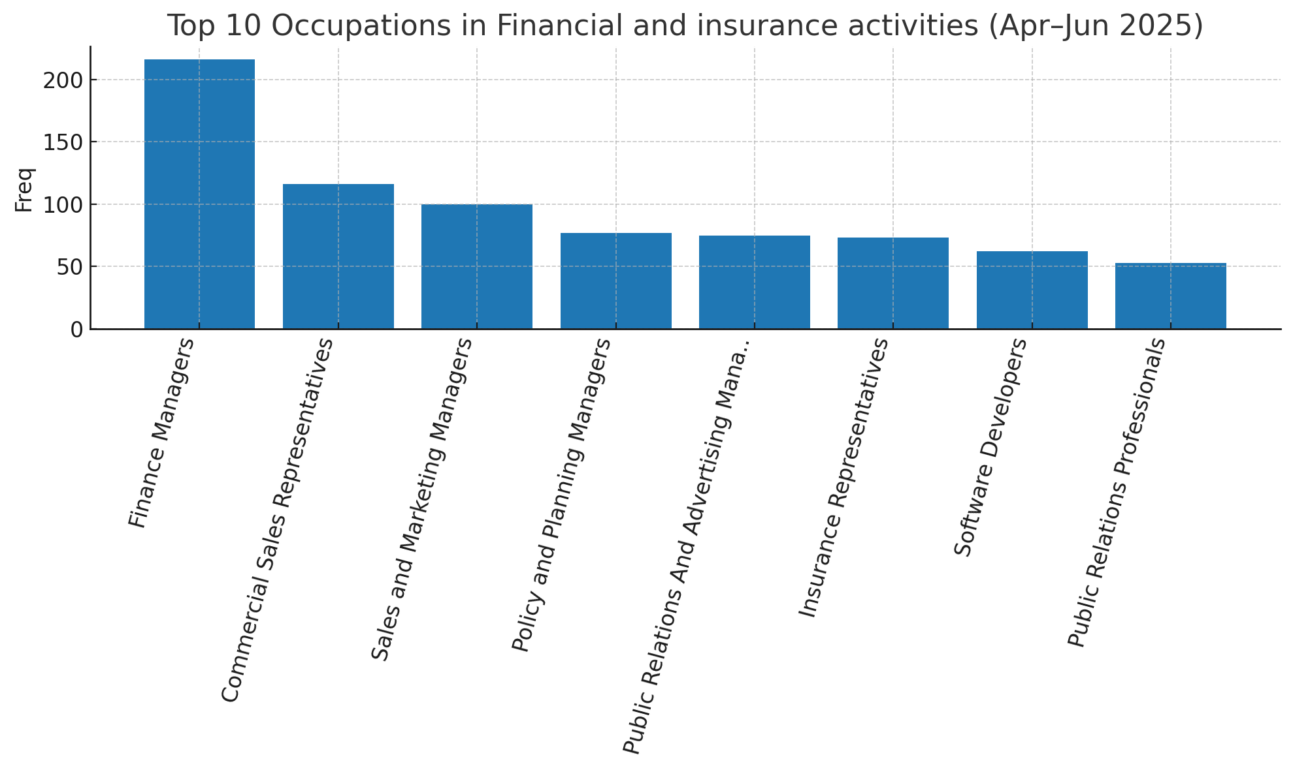

**Figure 8:Top Occupations in Financial and insurance activities**

Financial and Insurance Activities heavily recruited Finance Managers, Accountants, Loan Officers, and Actuaries, showing sectoral growth.

**4.4.4 Top 10 Occupations in Education sector**

Table 9: Top 10 Occupations in Education sector

|  |  |  |
| --- | --- | --- |
| **OCCUPATIONS** | **NUMBER OF VACANCIES** | **PERCENTAGE** |
| University and College Lecturers | 474 | 33.47 |
| Secondary Education Teachers | 86 | 6.07 |
| Primary School Teachers | 84 | 5.93 |
| Managing Directors and Chief Executives | 52 | 3.67 |
| Accountants | 30 | 2.12 |
| Administrative and Executive Secretaries | 28 | 1.98 |
| Personnel Clerks | 24 | 1.69 |
| Sales and Marketing Managers | 22 | 1.55 |
| Commercial Sales Representatives | 21 | 1.48 |
| Systems Analysts | 18 | 1.27 |

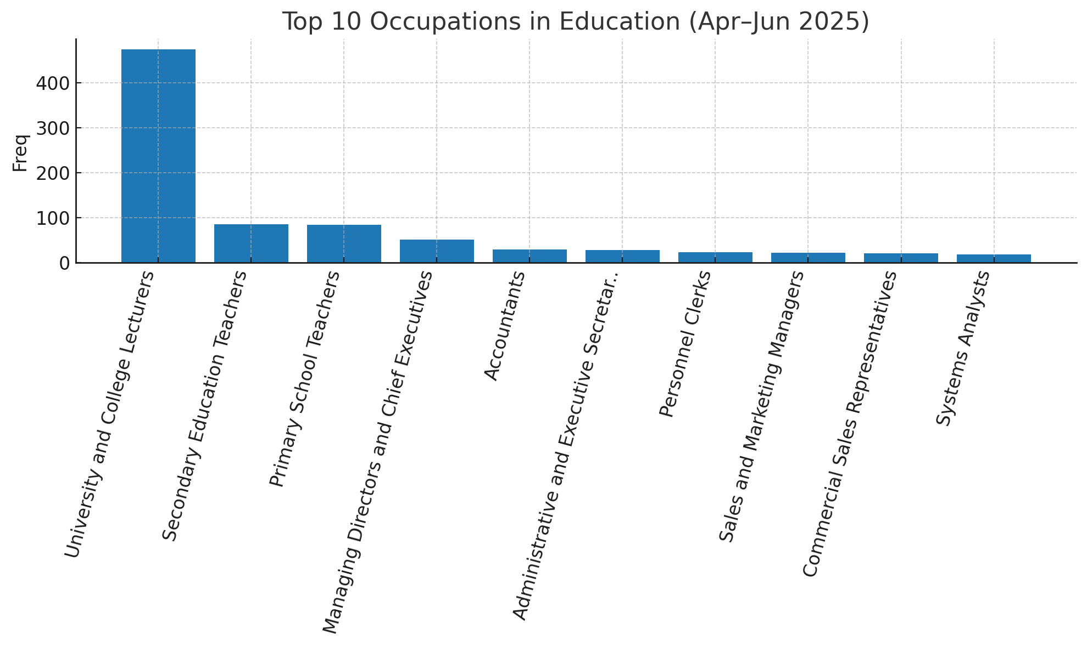

Figure 9:Top 10 Occupations in Education sector

Education sector demand focused on University Lecturers, Early Childhood Teachers, and Teacher’s Aides, pointing to expansion at all levels of learning.

**4.4.5 Top 10 Occupations in Administrative and support service activities**

Table 10: Top 10 Occupations in Administrative and support service activities

|  |  |  |
| --- | --- | --- |
| **OCCUPATIONS** | **NUMBER OF VACANCIES** | **PERCENTAGE** |
| Finance Managers | 216 | 13.47 |
| Commercial Sales Representatives | 116 | 7.24 |
| Sales and Marketing Managers | 100 | 6.24 |
| Policy and Planning Managers | 77 | 4.8 |
| Public Relations And Advertising Managers | 75 | 4.68 |
| Insurance Representatives | 73 | 4.55 |
| Software Developers | 62 | 3.87 |
| Public Relations Professionals | 53 | 3.31 |

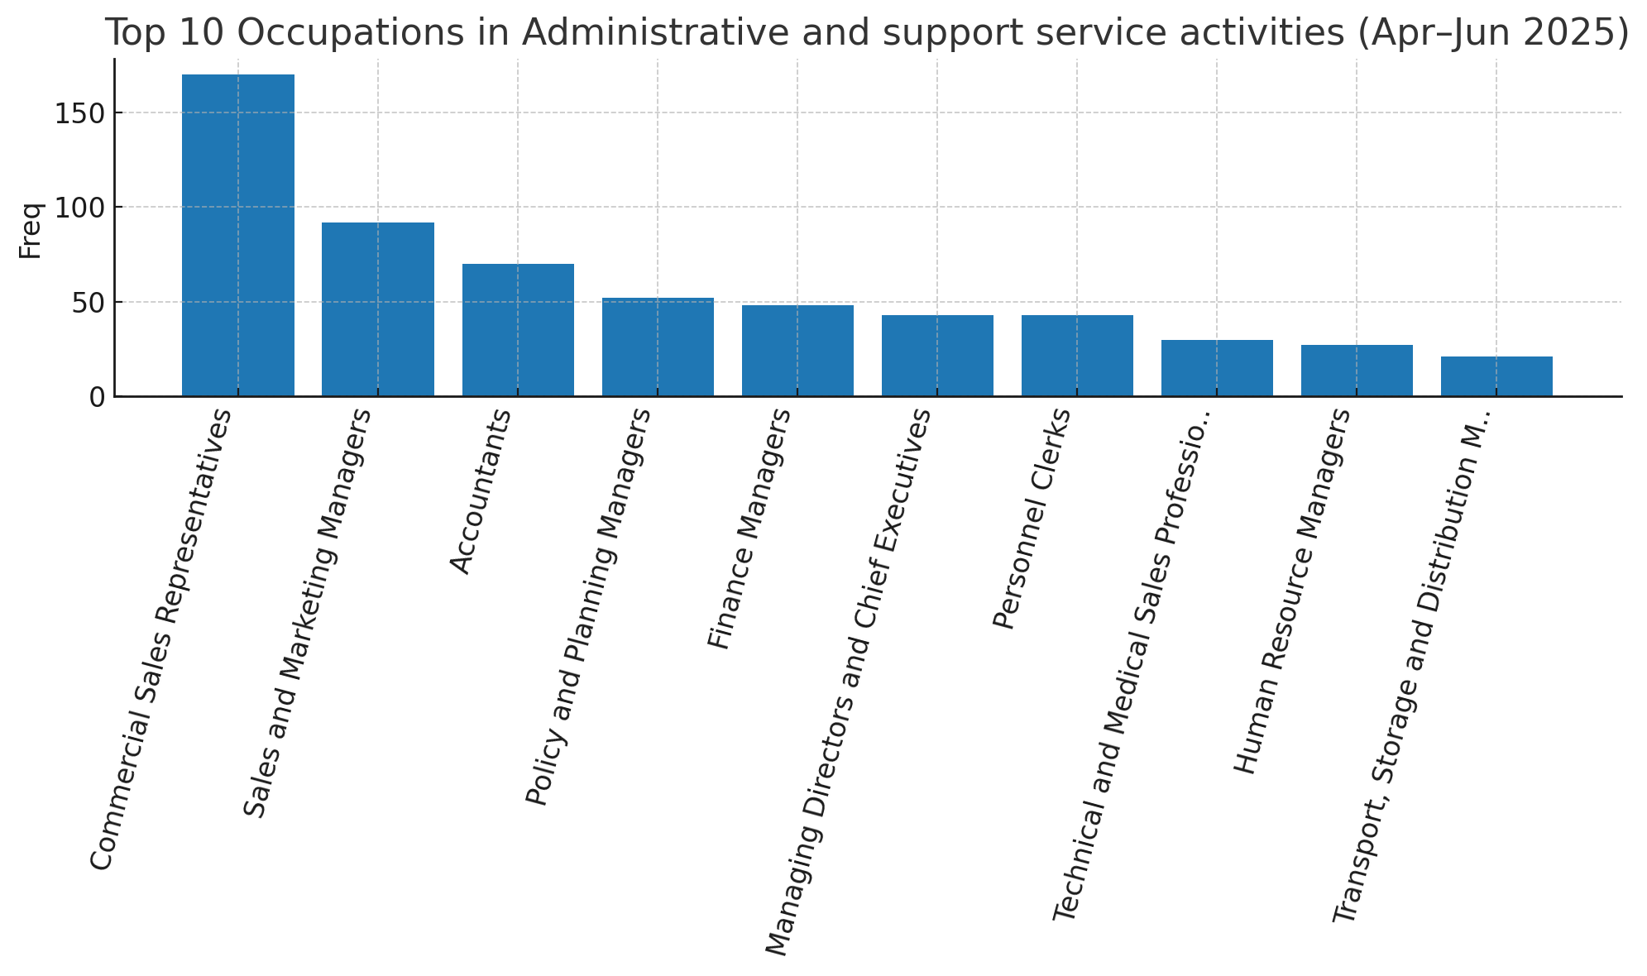

Figure 10: Top 10 Occupations in Administrative and support service activities

Administrative & Support Services hired Contact Centre Clerks, Secretaries, and Customer Support roles, highlighting reliance on administrative efficiency.

# 5. CONCLUSION

Quarter 4 (April–June 2025) highlighted Kenya’s labour market reliance on professionals, managers, and technicians. Sectoral demand was concentrated in finance, education, health, public administration, and support services. Low-skilled occupations contributed only marginally to job creation. Policy, training, and private-sector alignment will be crucial to sustain growth and address mismatches between supply and demand in the labour market.

# 6. RECOMMENDATIONS

* Expand professional and vocational training aligned to sectors with strong demand.
* Support mid-skill pipelines (clerical support, customer service, logistics) with targeted short courses.
* Stimulate private-sector hiring in underrepresented industries through investment and incentive frameworks.
* Maintain real-time vacancy monitoring to detect emerging occupations and skills.